**NUTRITION ASSISTANT APPLICATION**

|  |  |
| --- | --- |
| **TEAM ID** | **PNT2022TMID27311** |
| **TEAM MEMBERS** | **R.VARSHA**  **S.SANKARI**  **T.OOVIYA**  **M.UMADEVI** |

**SETTING UP APPLICATION ENVIRONMENT**

FLASK PROJECT CREATION:

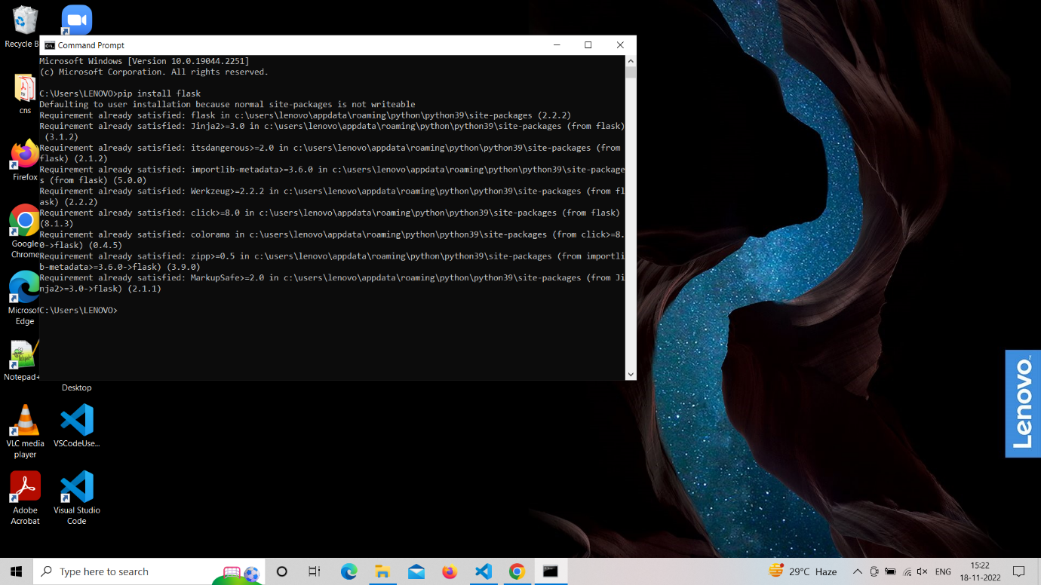

IBM CLOUD ACCOUNT CREATION:

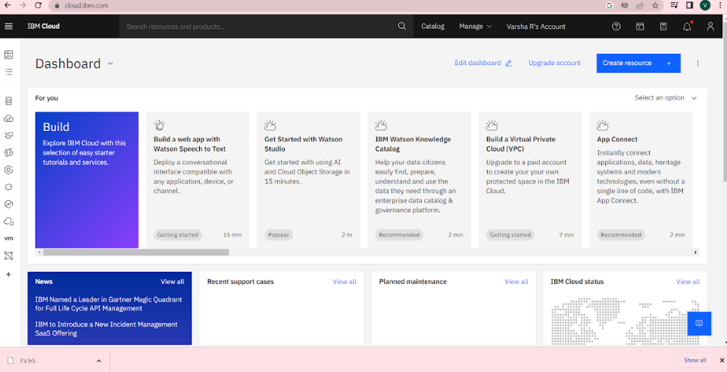

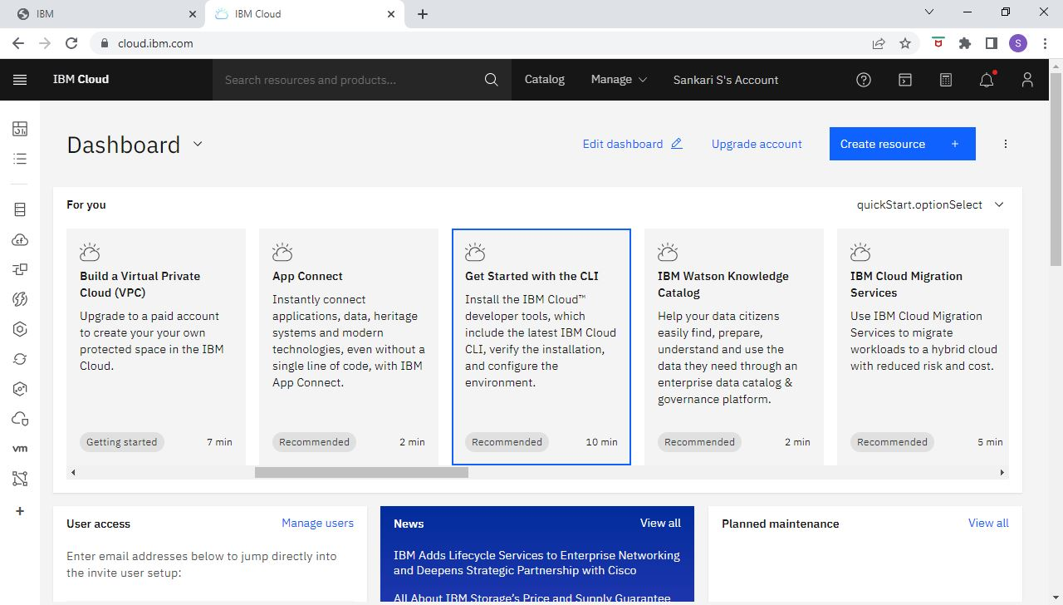

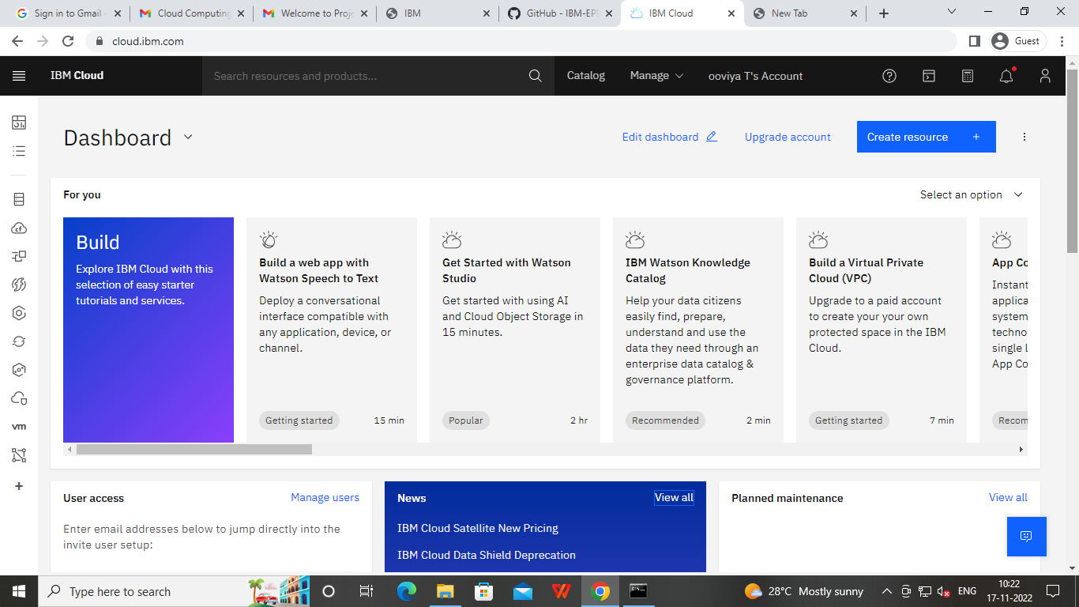

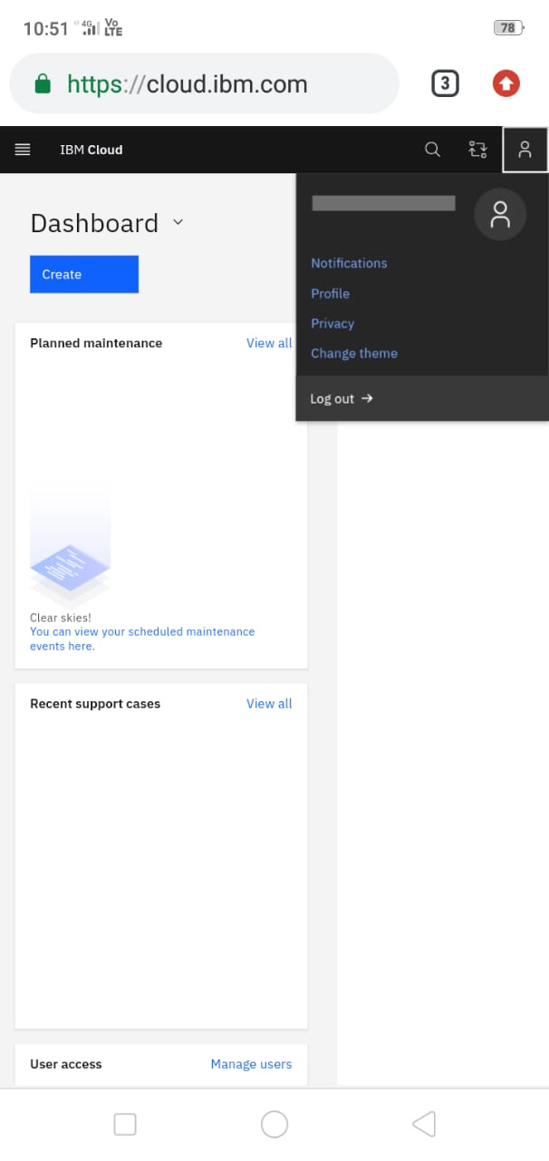

IBM CLOUD CLI INSTALLATION:

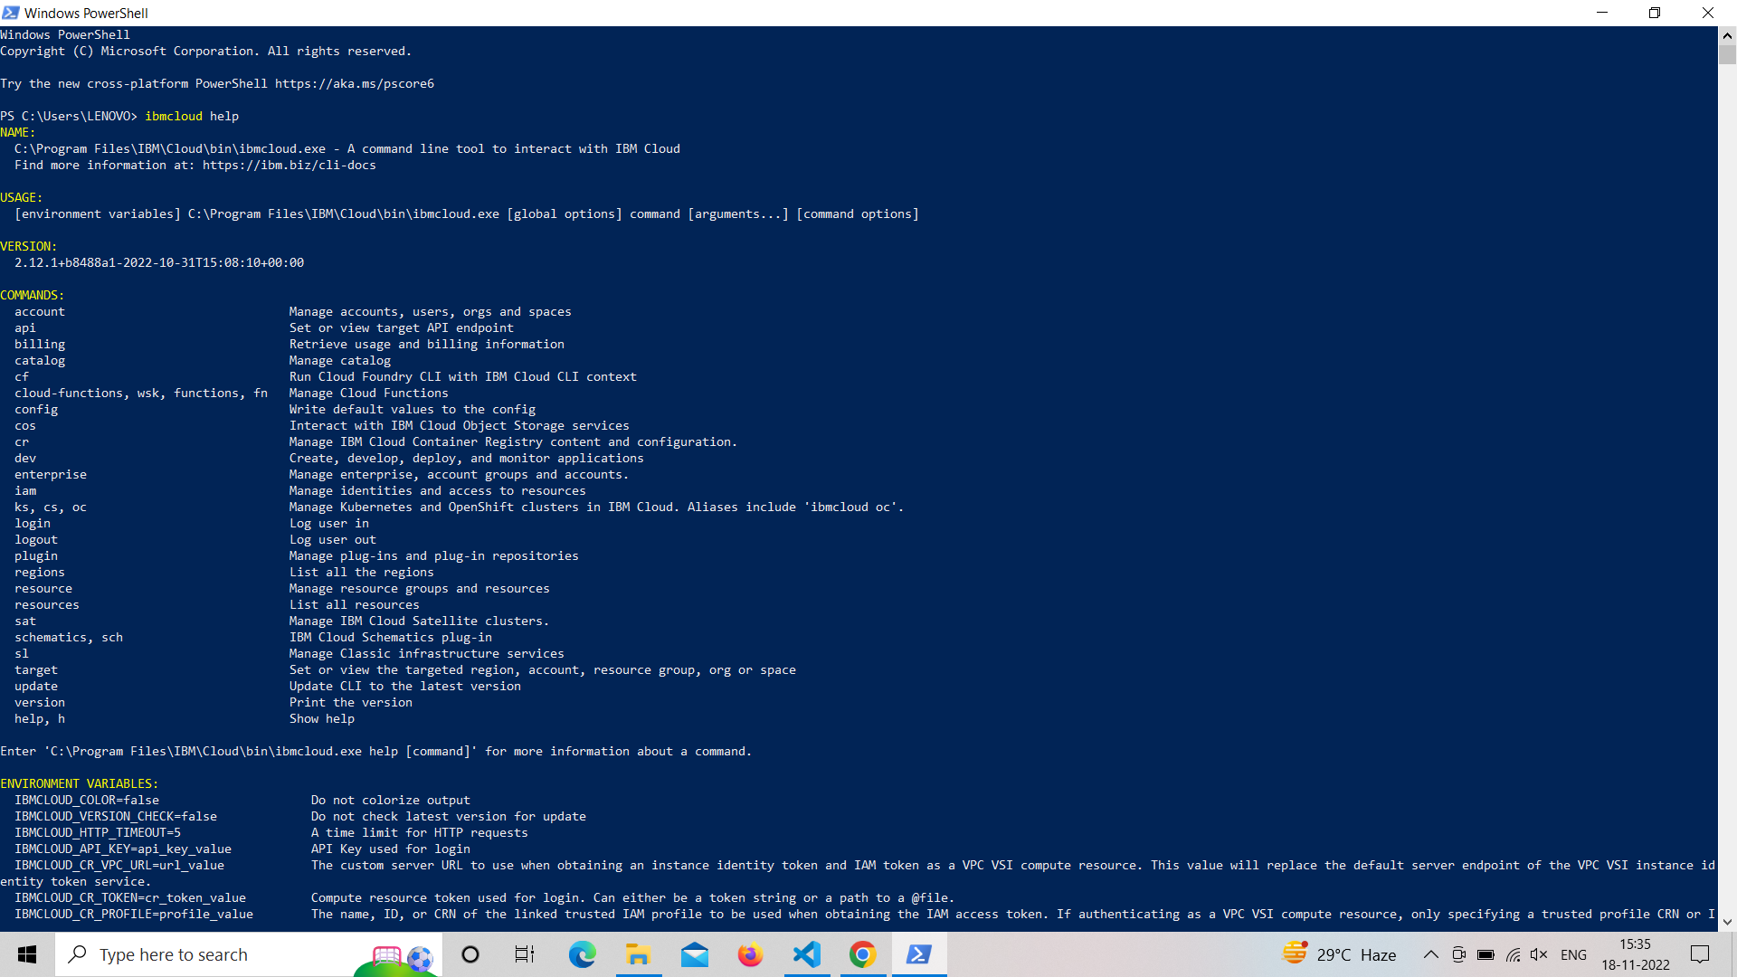

DOCKER CLI INSTALLATION:

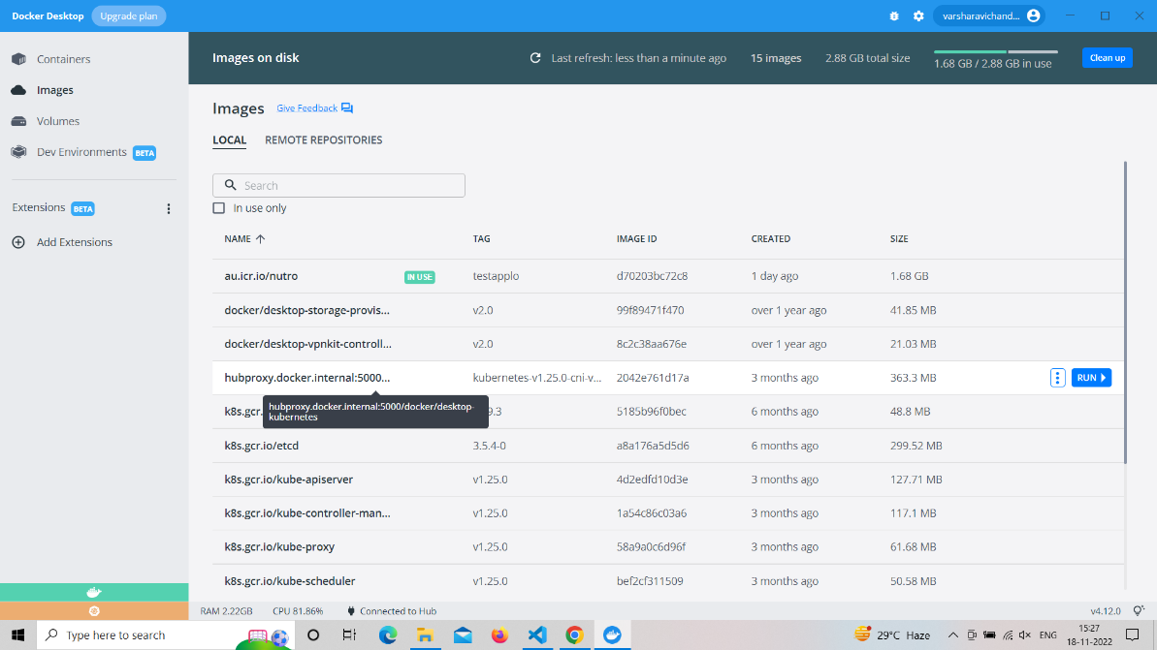

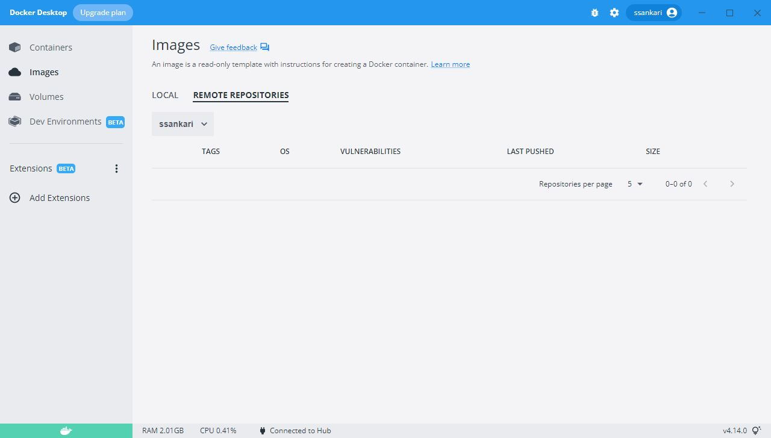

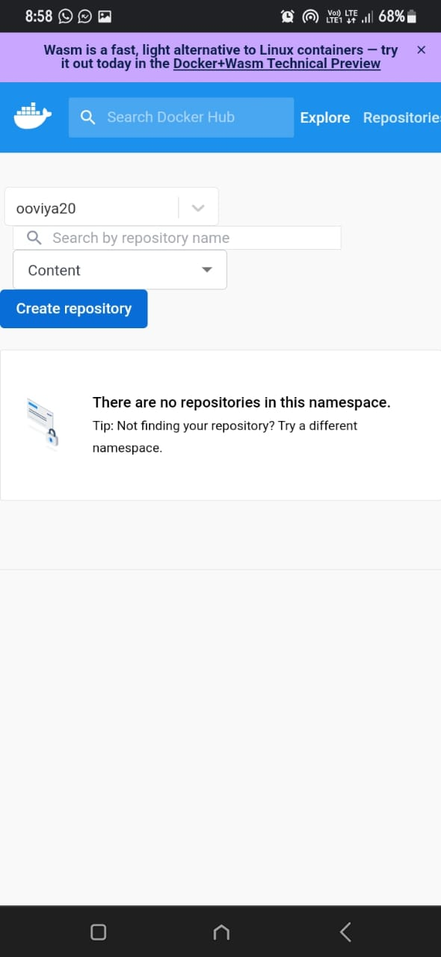 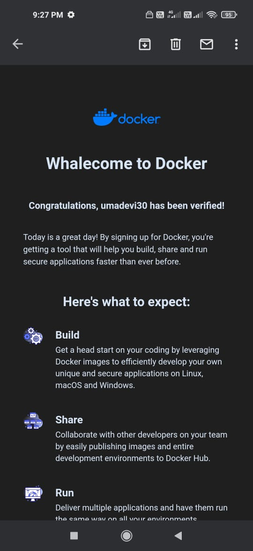

SENDGRID ACCOUNT CREATION: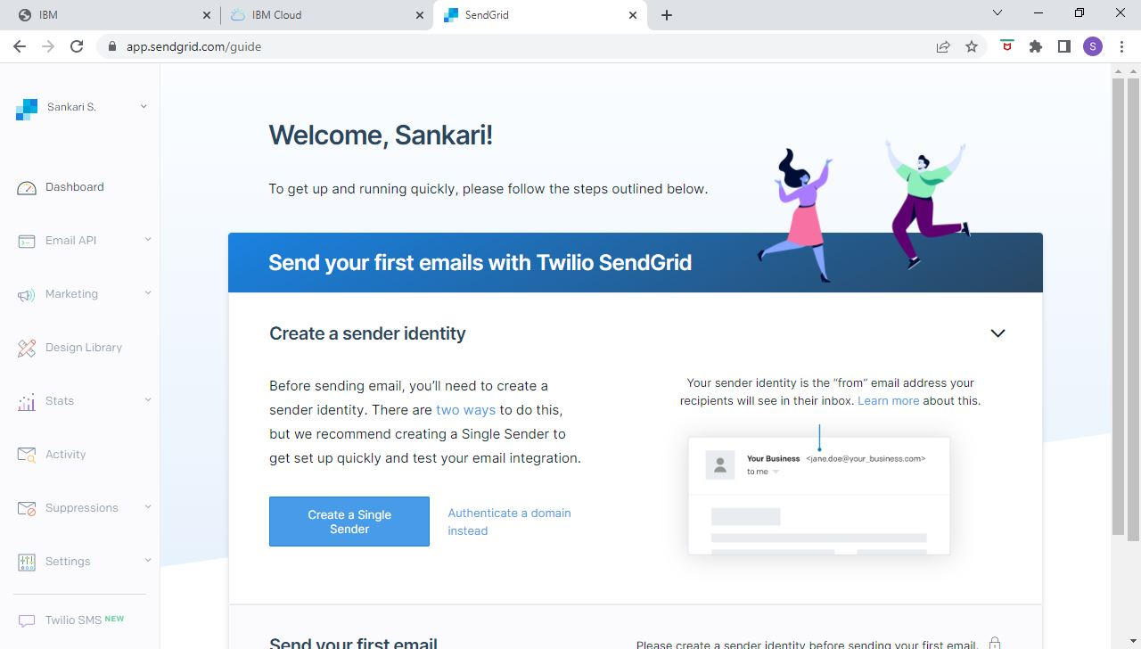

NUTRITION API ACCOUNT CREATION:

